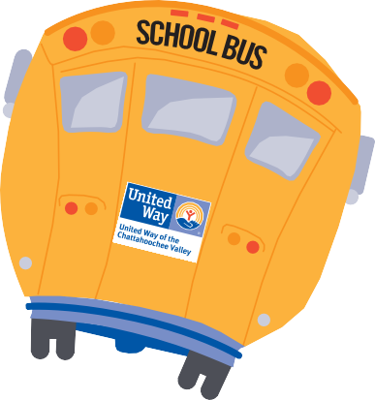

School Supplies List

(Pre-K – 2nd grade)

- Backpacks

- 3-Ring View Finder Binder (1”)

- Notebook paper (wide ruled)

- Composition notebooks (wide ruled)

- Markers (washable, classic colors, broad line)

- Crayons (24 pack)

- Erasers

- Glue sticks

- Scissors (rounded, for young children)

- # 2 Pencils (1 Dozen)

